Name: _________________________________
Draw a Diagram

Label the areas of the brain affected by alcohol .

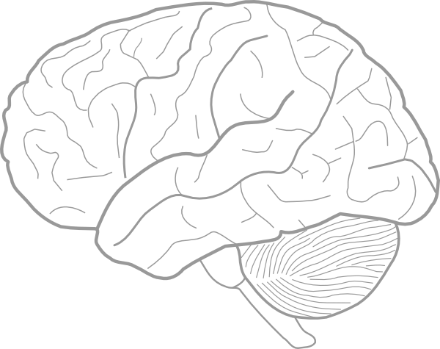

- What areas of the brain does alcohol affect? ________________________________________________________________________________________________________________________________________________________________________________________________________________________________________________________________________________________________________________________________________________________________________
- What functions do these areas of the brain carry out? ________________________________________________________________________________________________________________________________________________________________________________________________________________________________________________________________________________________________________________________________________________________________________
- What are the short-term effects of drinking and brain function? ________________________________________________________________________________________________________________________________________________________________________________________________________________________________________________________________________________________________________________________________________________________________________
- What can be long-term consequences of teenage drinking on brain development and function? ________________________________________________________________________________________________________________________________________________________________________________________________________________________________________________________________________________________________________________________________________________________________________
- How does drinking affect a teenage brain versus an adult brain? ________________________________________________________________________________________________________________________________________________________________________________________________________________________________________________________________________________________________________________________________________________________________________

